Discretized Neural Network (Discrete NN)

Epsilon = 0.05 (misclassified)

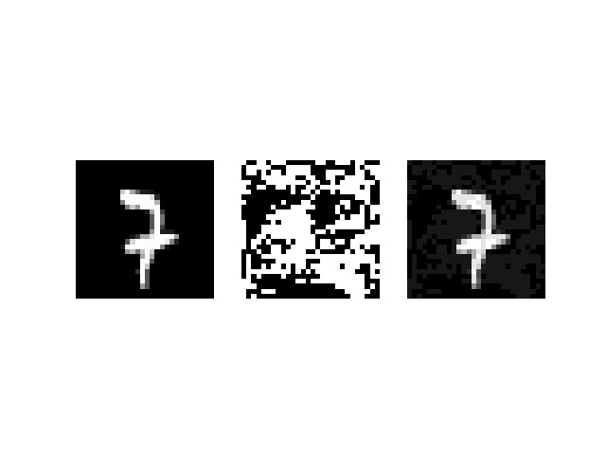
Epsilon = 0.05 (correctly classified)

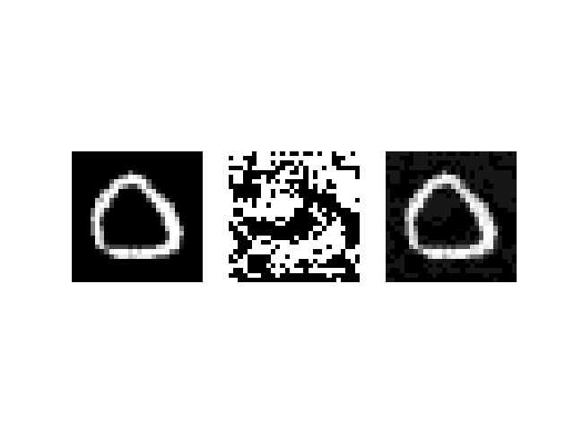

Epsilon = 0.07 (misclassified)

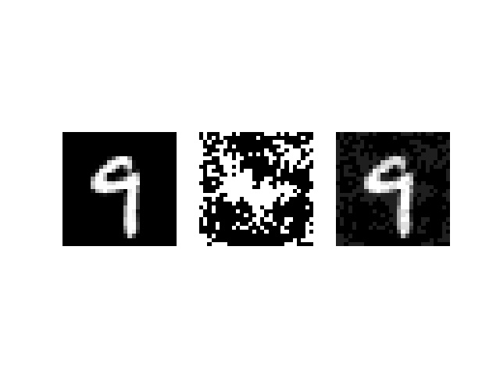
Epsilon = 0.07 (correctly classified)

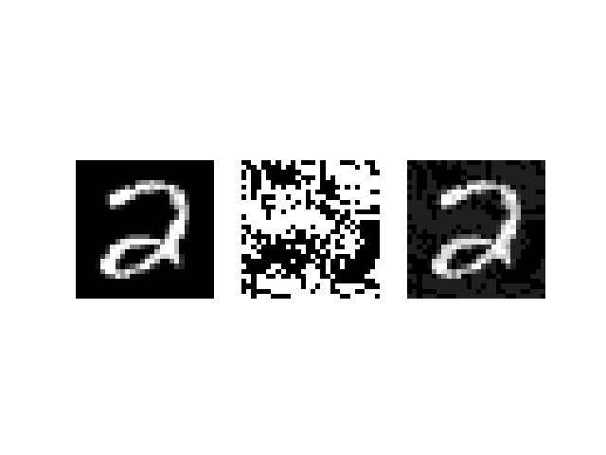

Epsilon = 0.1 (misclassified)

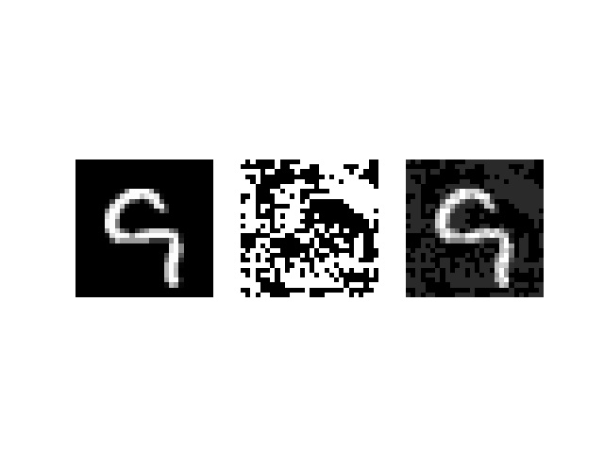

Epsilon 0.1 (correctly classified)

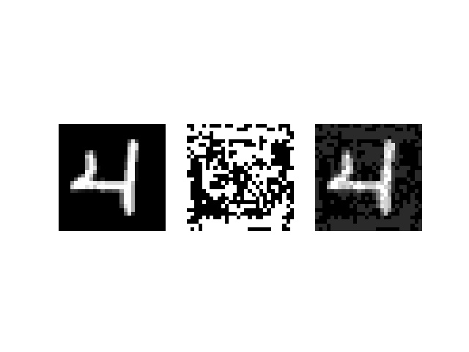

Epsilon 0.3 (misclassified)

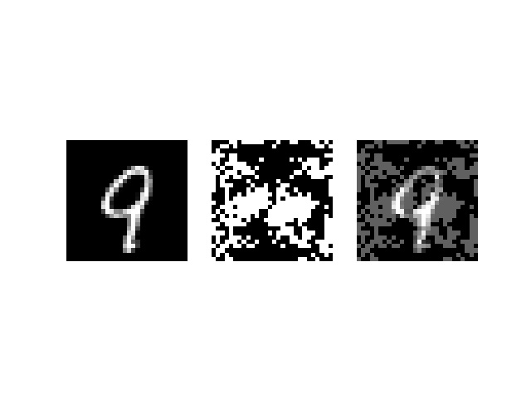
Epsilon 0.3 (correctly classified)

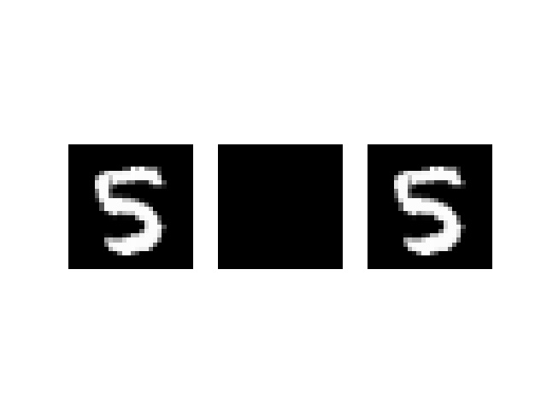

Epsilon 0.5 (misclassified)

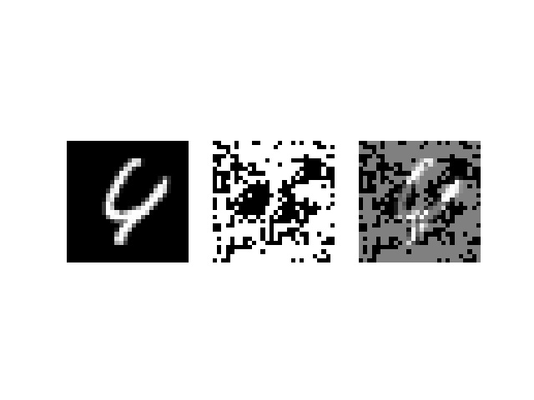

Epsilon 0.5 (correctly classified)

